January 26, 2026

Mr. John Oliver P. Brioso
Director
FEU Industry Internship and Instructions
Far Eastern University

LETTER OF INTENT
For Career Development, School Engagement, and Internship Collaboration

Dear Mr. Brioso,

Sadsad Tamesis Legal and Accountancy Firm (STLAF) respectfully expresses its intent to establish a strategic partnership with Far Eastern University (FEU) in support of student career development, professional exposure, and internship opportunities.

STLAF is a professional services firm providing integrated legal and accountancy solutions. In line with our commitment to talent development and industry–academe collaboration, we seek to actively engage with FEU by participating in career-oriented initiatives that prepare students for professional practice and workplace readiness.

Through this partnership, STLAF intends to support the University’s career development and employability programs by participating in activities such as career fairs, school talks, seminars, and guest lectures, as may be scheduled by the University. In addition, STLAF offers structured internship and On-the-Job Training (OJT) programs for qualified students enrolled in the following courses:

- Accounting
- Human Resource Management
- Marketing
- Corporate / Business Administration–related programs
- Legal Management / Pre-Law (Litigation Support)
- Information Technology

All engagements and activities shall be fully aligned with the University’s academic calendar, institutional policies, and internship requirements. Specific schedules, formats, and coordination details shall be discussed and finalized in consultation with FEU’s designated representatives.

This Letter of Intent signifies STLAF’s commitment to building a long-term and mutually beneficial partnership with Far Eastern University, with the shared objective of enhancing student employability and strengthening industry linkages.

We would be honored to discuss this proposed collaboration further at your convenience. Thank you for your time and consideration.
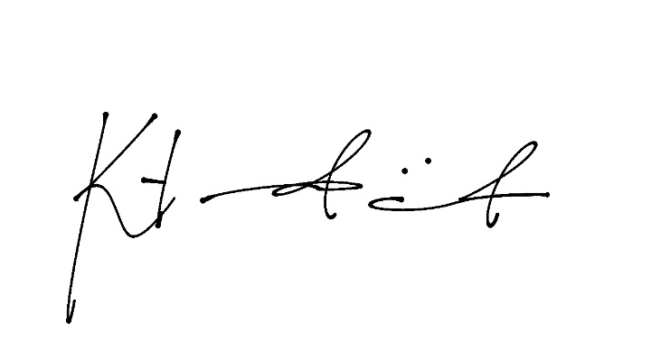
Respectfully yours,

Katrina Pauline M. Trinidad, CHRA
Head of HR Department
Sadsad Tamesis Legal and Accountancy Firm (STLAF)

